**Experiment No.8**

**Aim:**  Edit/compile/run a program to duplicate all the elements of a list.

**Program A: Brute force approach**

def duplicate(li):  
 n=len(li)  
 dup=[]  
 for i in range (n):  
 k = i+1  
 for j in range(k,n):  
 if li[i] == li[j] and li[i] not in dup:  
 dup.append(li[i])  
 return dup  
  
li=[28,9,30,6,2,7,9,28,10,7,24]  
print("Duplicate integers are: ",duplicate(li))

**Output:**

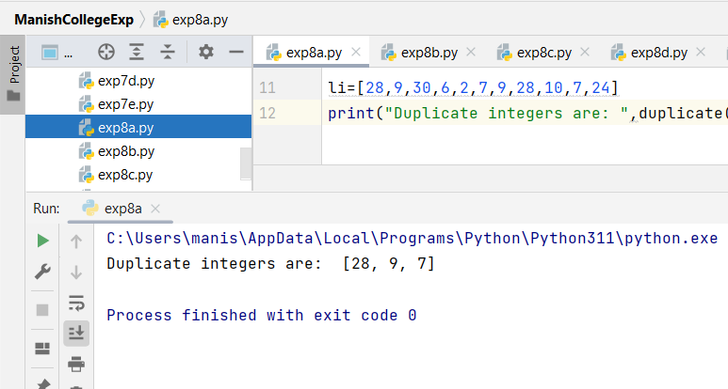

**Program B: Counter function**

from collections import Counter  
  
li = [99,66,547,25.41,2789,5468,111,25.41,66,2789]  
d = Counter(li)  
  
repeated_list = list([num for num in d if d[num]>1])  
print("Duplicate integers are: ",repeated_list)

**Output:**

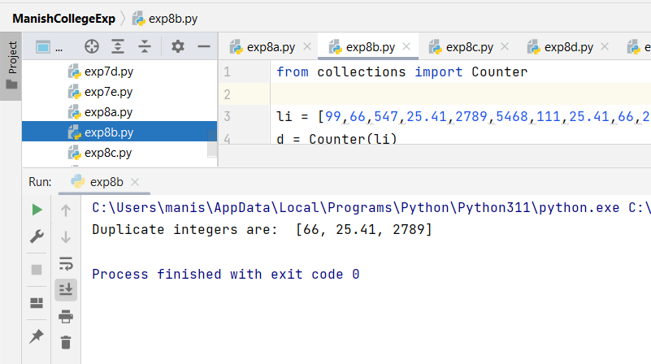

**Program C:** **Using a single for loop**

list=[24,28,357,159,862,248,862,159,357]  
uniqueList = []  
duplicateList = []  
  
for i in list:  
 if i not in uniqueList:  
 uniqueList.append(i)  
 elif i not in duplicateList:  
 duplicateList.append(i)  
  
print(duplicateList)

**Output:**

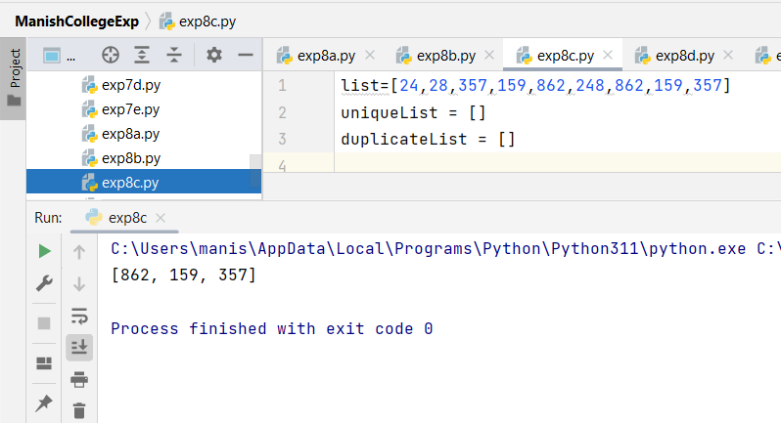

**Program D:** **To find duplicate characters in a list**

str = "Chhatrapati Shivaji Maharaj ki Jay"  
  
duplicate_char = []  
for character in str:  
  
 if str.count(character) > 1:  
  
 if character not in duplicate_char:  
 duplicate_char.append(character)  
print(*duplicate_char)

**Output:**

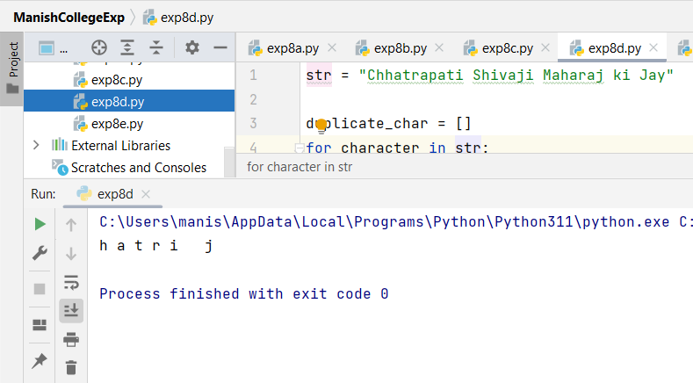

**Program E:** **To find duplicate characters from list using Counter function.**

from collections import Counter  
  
  
def find_dup_char(input):  
  
 WC = Counter(input)  
  
 for letter, count in WC.items():  
 if (count > 1):  
 print(letter)  
  
  
if __name__ == "__main__":  
 input = 'Yada yada hi dharmasya glanirbhavatim bharatah'  
 find_dup_char(input)

**Output:**

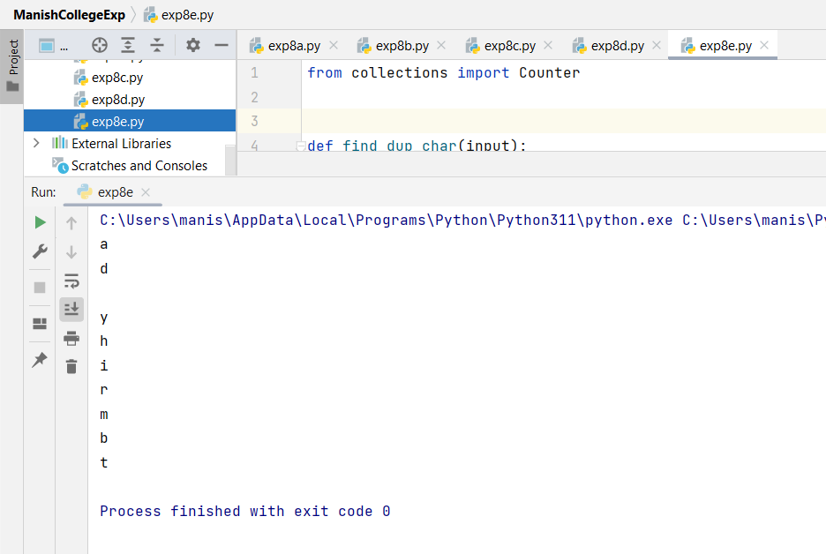

|  |  |  |  |
| --- | --- | --- | --- |
| **Practical Performance**  **(4)** | **Writeup & Oral**  **(4)** | **Attendance**  **(2)** | **Total**  **(10)** |
|  |  |  |  |